**Interobserver Agreement Definitions**

*Directions: The first half of this worksheet includes definitions and formulas for various interobserver agreement procedures (IOA). After reading through the document to familiarize yourself with the various methods, practice recording and calculating IOA with the IOA Practice Worksheet.*

**Definition**: Interobserver agreement (reliability) refers to the extent to which observers agree in their scoring of behaviors.

**Requisites**:

Observers must use the same measurement system

Observers must measure the same events

Observers must be independent

1. **Event recording**: Comparing the two totals (total of observer 1 and observer 2)
   1. **Total count IOA*:*** *Smaller count/Larger count X 100*
      1. Use Caution with Total count IOA
         1. High degree of agreement provides no assurance that the two observers recorded the same instances of behavior
      2. Better alternative: ***Mean count-per-interval IOA=***

*(Int 1 IOA + Int 2 IOA + Int N IOA/ n intervals) X 100*

**Considerations**:

When a frequency ratio yields a percentage agreement of 90%

Does not mean that observers agreed 90% of the time

Does not mean that observers agreed on 90% of the behaviors that occurred.

The ratio merely reflects how close the totals fell to each other.

1. **Duration recording:** allows you to obtain a measure of length of time a behavior occurs.
   1. **Total duration IOA:** *Smaller duration/Larger duration x 100*
      1. Limitation- Again, provides no assurance same durations being recorded for same occurrences of behavior
      2. Better alternative: mean duration-per-occurrence IOA

**Considerations**:

As with total count IOA for event recording data, high total duration IOA provides no assurance that the observers recorded the same durations for the same occurrences of behavior.

1. **Interval IOA**: Rather than looking at totals, agreement is evaluated on a response-by-response or point-by-point:
   1. **Interval-by-interval IOA:** *A (Agreements) /A (Agreements)+D (Disagreements) x100=%IOA*
      1. Only those intervals in which either or both observers recorded the *occurrence* of the target behavior are used
      2. Requires the observer to record whether the behavior was present or absent at any time during the interval

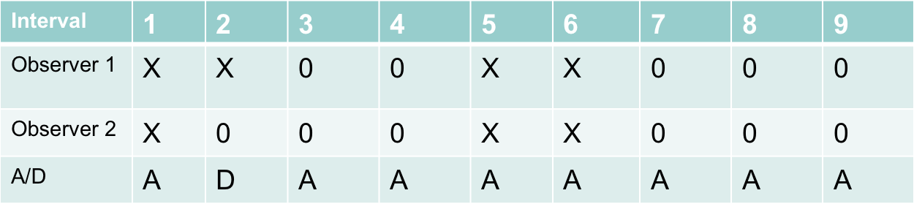

Total Agreements: 8 Total Disagreement: 1

8(Agreements)/8+1(Disagreements) =8/9 x100=88.88%

* 1. **Scored-interval IOA:** *A (Agreements) /A (Agreements)+D (Disagreements) x100=%IOA*
     1. Only those intervals in which either or both observers recorded the *occurrence* of the target behavior are used

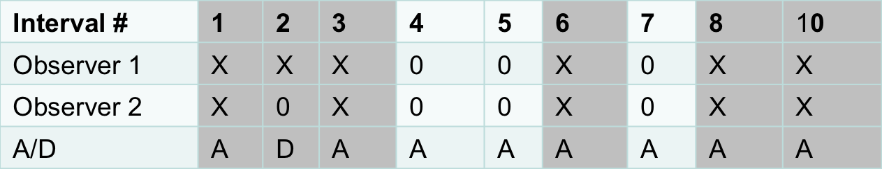

Total Agreements:5 Total Disagreement: 1

(5A/(5A + 1D) ) X 100 = ((5/6) X 100) = 83% IOA

* 1. **Unscored-interval IOA:** *A (Agreements) /A (Agreements)+D (Disagreements) x100=%IOA*
     1. Only those intervals in which either or both observers recorded the *nonoccurrence* of the target behavior are used

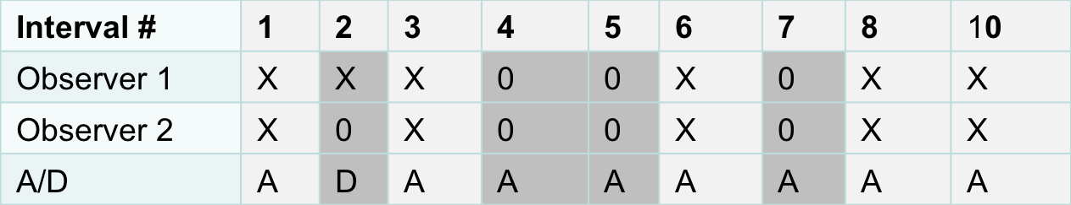

TotalAgreements: 3 Total Disagreement: 1

(3A/(3A + 1D) ) X 100 = ((3/4) X 100) = 75% IOA

* **Partial-interval recording**: Requires the observer to record whether the behavior was present or absent at any time during the interval
* **Whole-interval recording**: Requires the behavior to be present throughout the entire interval to be considered an occurrence by the observer

**Overall considerations:**

More stringent and conservative methods of calculating IOA should be used over methods that are likely to overestimate actual agreement as a result of chance.

If in doubt about which form of IOA to report, calculating and presenting several variations will help readers make their judgments regarding believability of the data.